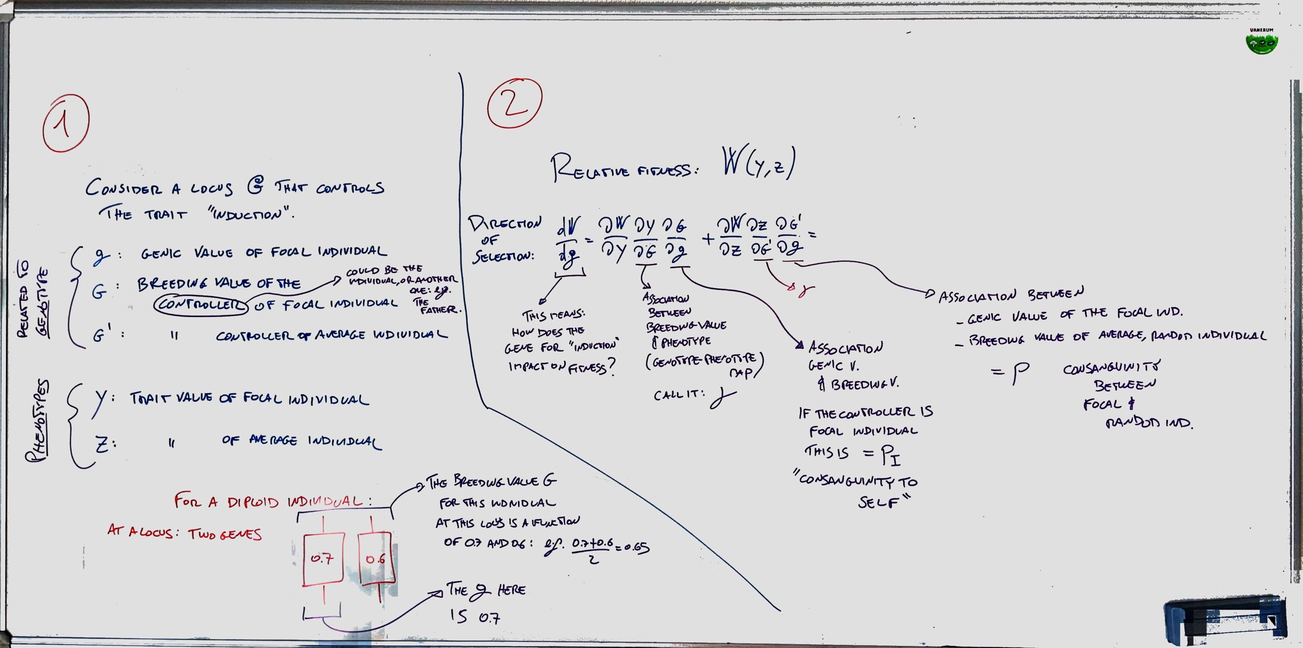

For example, the fitness function in Frank (1998)

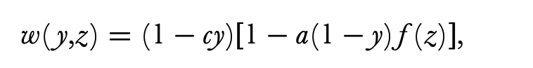

From Micheletti et al 2017, Supporting Information.

“The coefficient of **consanguinity** *p*A,B between two individuals A and B is defined as the probability that a gene drawn at random from a given locus in individual A is identical-by- descent to a gene drawn at random from the same locus in individual B (Bulmer 1994)”

“The coefficient of **relatedness** *r*A,B between two individuals A and B is defined as the ratio of the consanguinity of individual B to individual A, *p*A,B , and the consanguinity of individual B to herself, *p*B,B

(Bulmer 1994)”

